|  |
| --- |
| Rolsa |
| A Digital Solution |
| Design Documents |

Contents

Design of the site 3

Inspiration 3

Non-eco focused websites 3

Proposal 6

Click maps 8

Hand drawn wire frames (subject to mild alteration) 10

High fidelity designs (subject to mild alteration) 14

Data requirements 18

Database 18

Hand drawn table design 18

General Notes 18

USERS 19

CARBON_FOOTPRINTS 19

BOOKINGS 19

Data dictionary 19

PHP variables 19

SCSS/CSS variables 20

TypeScript/JavaScript variables 20

Algorithm design 21

Initialisation of site 21

User sign up 22

Edit user account details 24

Make a calculation 25

Delete a booking 27

Test strategies 28

Importance of testing 28

Types of strategies that can be used 28

Black box 28

White box 29

Code walkthrough 29

Static code analyses 29

Mutation testing 29

Data flow test 29

Unit testing 29

Acceptance testing 29

Performance testing 29

Test plan 29

# Design of the site

## Inspiration

From my own time of looking about of things to do and traveling I found a few websites I just for no other reason like, and I plan on taking some design inspiration from as the solution should be pleasing to the eye for the UI (user interface).

### Non-eco focused websites

In Latitude festival’s (https://www.latitudefestival.com/) footer of their website sits nicely with me:

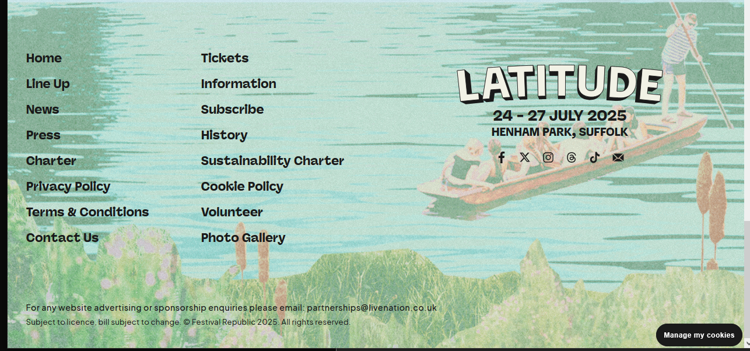

The navigation bar used by OverOslo (https://www.overoslo.no/) sits on the page very nicely and I hope to take and use its simple material like design:

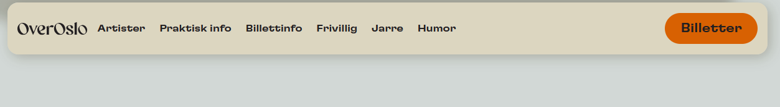

The hierarchy found from the railways in Germany (https://www.bahn.de/) has a very easy to understand sizing about it, it follows the golden rule, being 1.6x time larger than its child element.

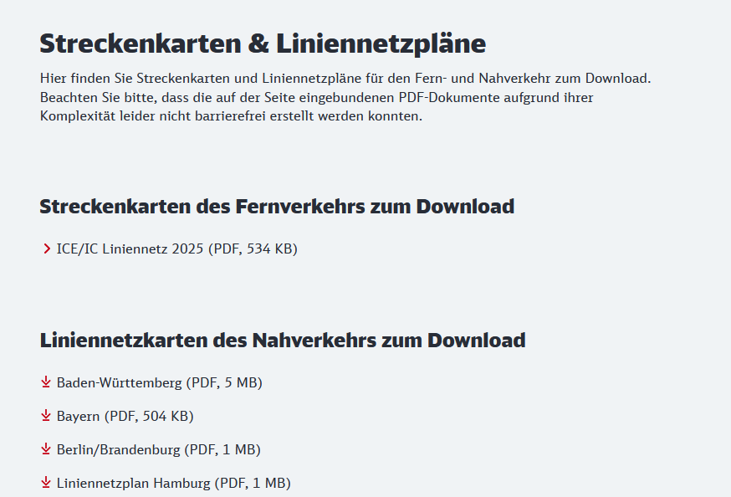

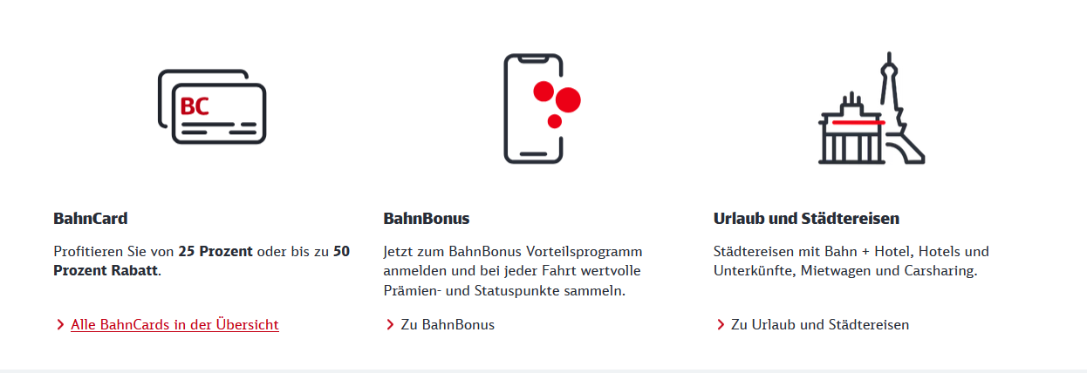

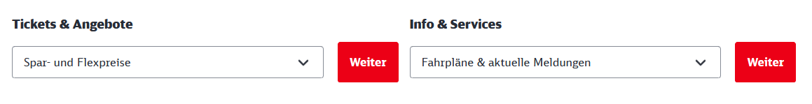

#### Eco focussed websites

They mark the predominant use of green to promote the idea of going green, places often use clean fonts.

From Energy Saving Trust (<https://energysavingtrust.org.uk/advice/solar-panels/>) an organisation based on making and maintaining cleaner and greener power networks.

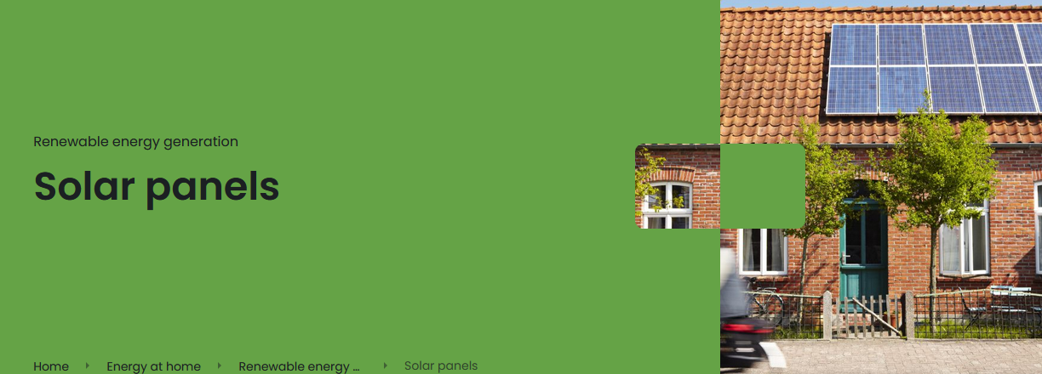

From the car company Škoda (https://www.skoda.co.uk/electric-hybrid-cars/electric) electric cars:

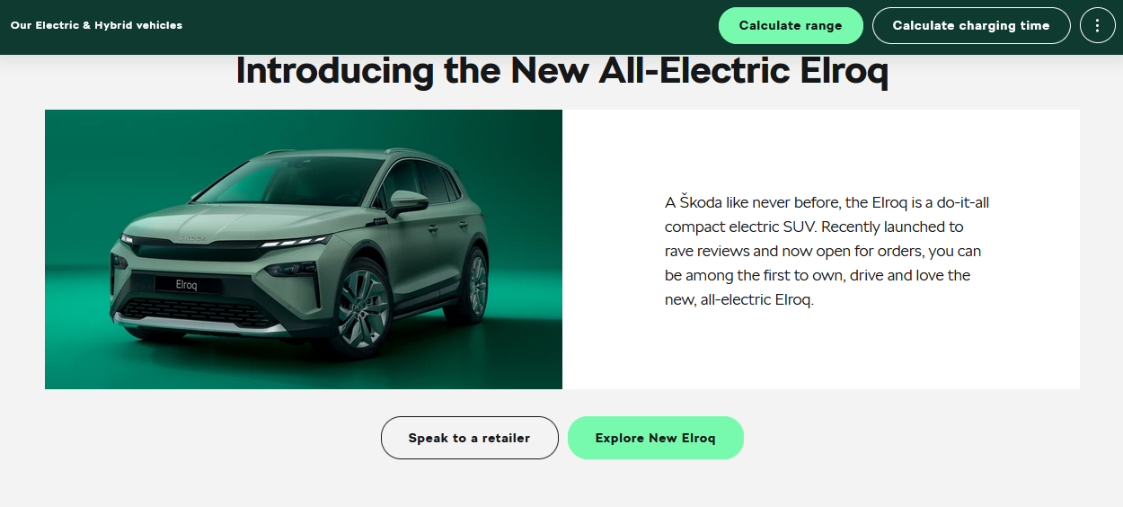

From Ecotricity (https://www.ecotricity.co.uk/) a green energy company has this for their hero page:  
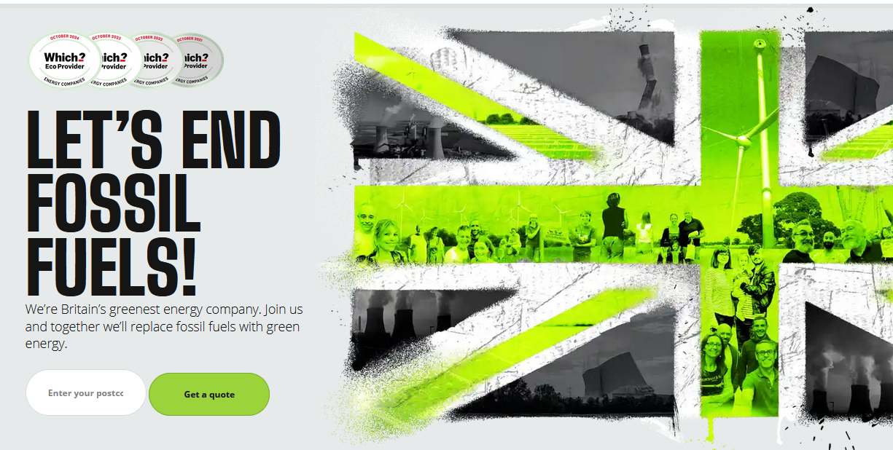

From a site that supplies industry standard colours (<https://www.color-name.com/cover/eco-green.png>):

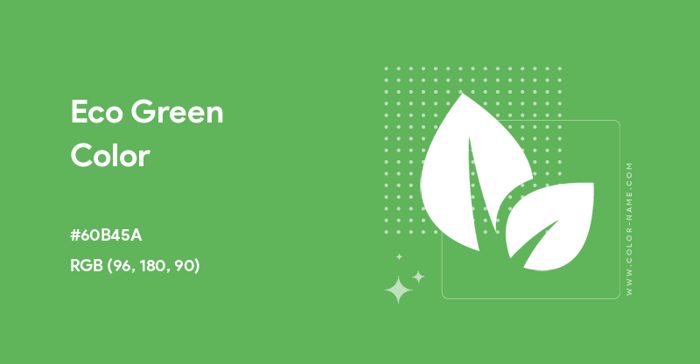

Greens found from an electric mobility scooter company Green Power (<https://www.mobilitypower.co.uk/>):



From Canva a free online photo editing suite had a little to say in a blog (<https://www.canva.com/logos/color-psychology-the-logo-color-tricks-used-by-top-companies/>):

Greens are often used by companies in technology and by those who want to appear eco-friendly, or luxury. Examples are BP, M&S, and John Dear. Green is associated with the outdoors.

The primary colours are used by brands who want to be striking or to show to their customers that they are economical, example such as MacDonalds, Walmart, and the BBC.

Purples are used by brands who want to be unique, quirky, or novelty. In history purple has been a very difficult colour to get as it is also seen with royalty.

Orange is associated with liveliness, energy, and action.

Blues are used to convey a feeling of sturdiness and security seen in companies who they want you to trust with money like Barclays, Visa, PayPal.

### Proposal

#### Colours

Green is used in industry for environmental companies as to make them appear more environmentally friendly, as such two greens have been picked for this, one lighter than the other.

Blue is used to show security. A lack of risk with a company as customers care less for the brand name and more the associated risk with any one name. A blue that nicely complements the two greens has been chosen for this.

I read on this forum (<https://graphicdesign.stackexchange.com/questions/25356/why-not-use-pure-black-000-and-pure-white-fff>) on graphic design about not using pure white or pure black for their purposes instead using some different colours, for white I’ve gone with a colour called snow white, and for black I’ve gone with a colour called dark-chocolate.

I then ran the colour through a colour contrast check for accessibility (<https://webaim.org/resources/contrastchecker/>) and here is the table for what colours can be used on what

|  |  |  |  |  |  |
| --- | --- | --- | --- | --- | --- |
| Background -> foreground \/ | Primary | Secondary | Tertiary | White | Black |
| Primary |  | Fail | Fail | Fail | Pass |
| Secondary | Fail |  | Fail | Pass | Fail |
| Tertiary | Fail | Fail |  | Pass | Pass |
| white | Fail | Pass | Pass |  | Pass |
| Black | Pass | Fail | Pass | Pass |  |

The colour palate should look like this, taken from design inspired by the above each colour picked for its purpose:

/* CSS HEX */

--primary: #60b450;

--secondary: #33642b;

--tertiary: #427676;

--white: #ecf1ed;

--black: #140300;

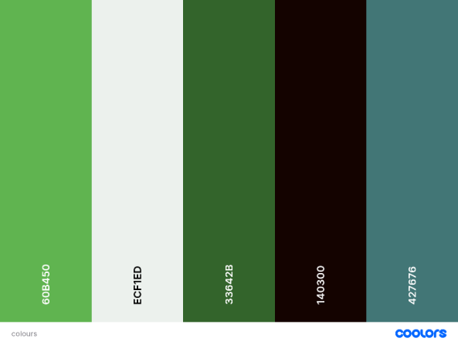

A test of the palate:  


#### Tech stack

Front end:

* HTML
* PHP
* SCSS
* TypeScript

Backend:

* PHP
* SQL

### Click maps

Click maps are the drawn-out method of how the user will go and navigate any one part of the system, none of these should be more than 5 stages long, this will show me if there are any parts that need to be reworked for the UX (user experience).

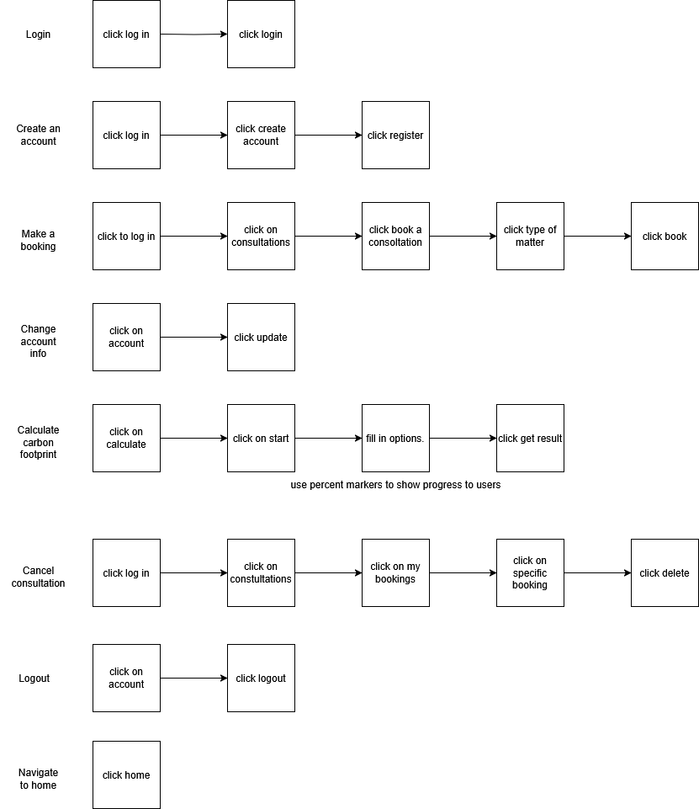

### Hand drawn wire frames (subject to mild alteration)

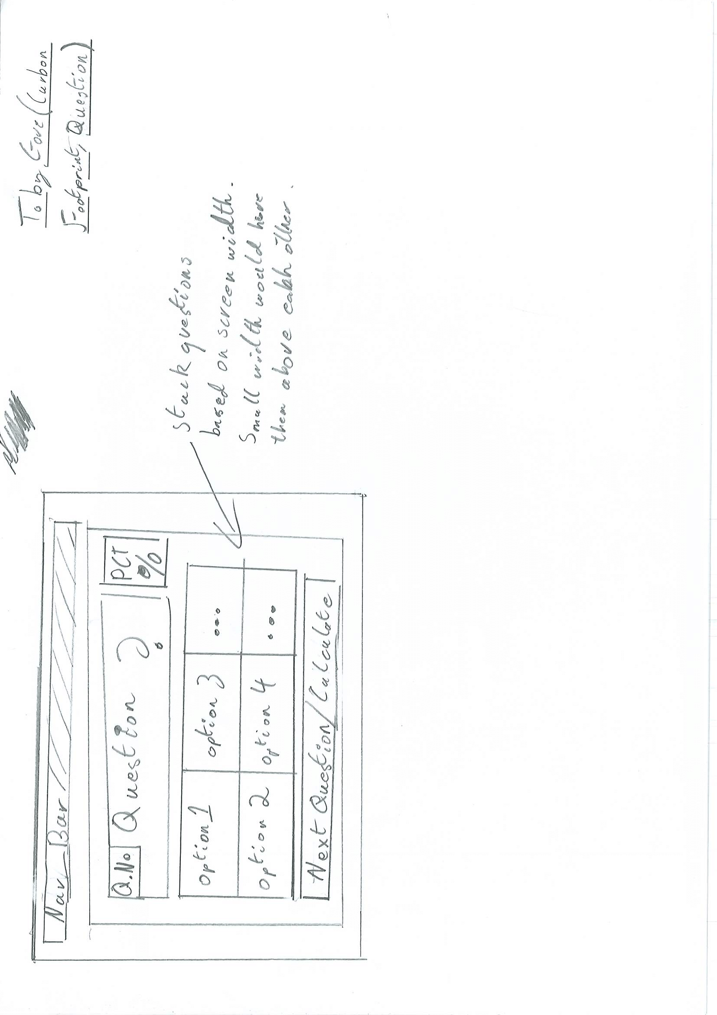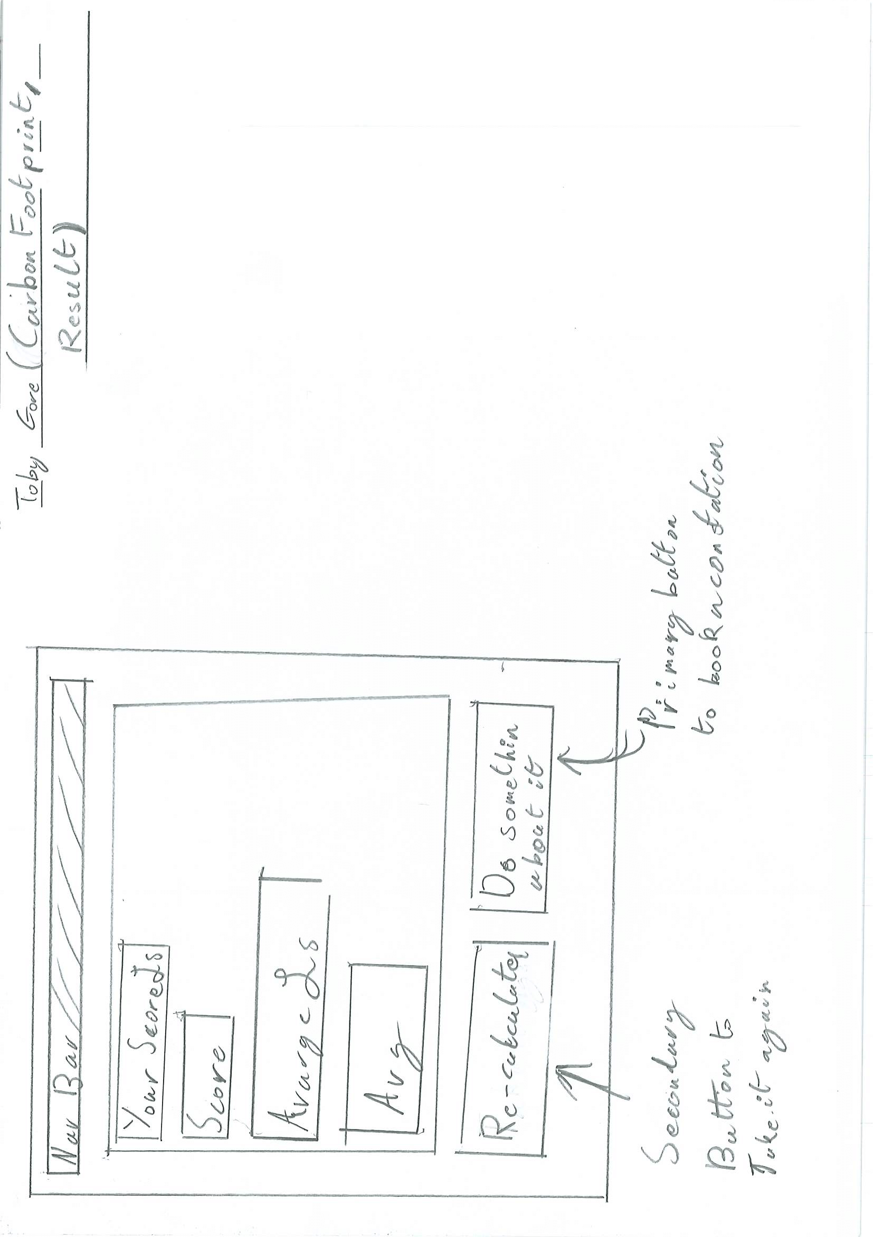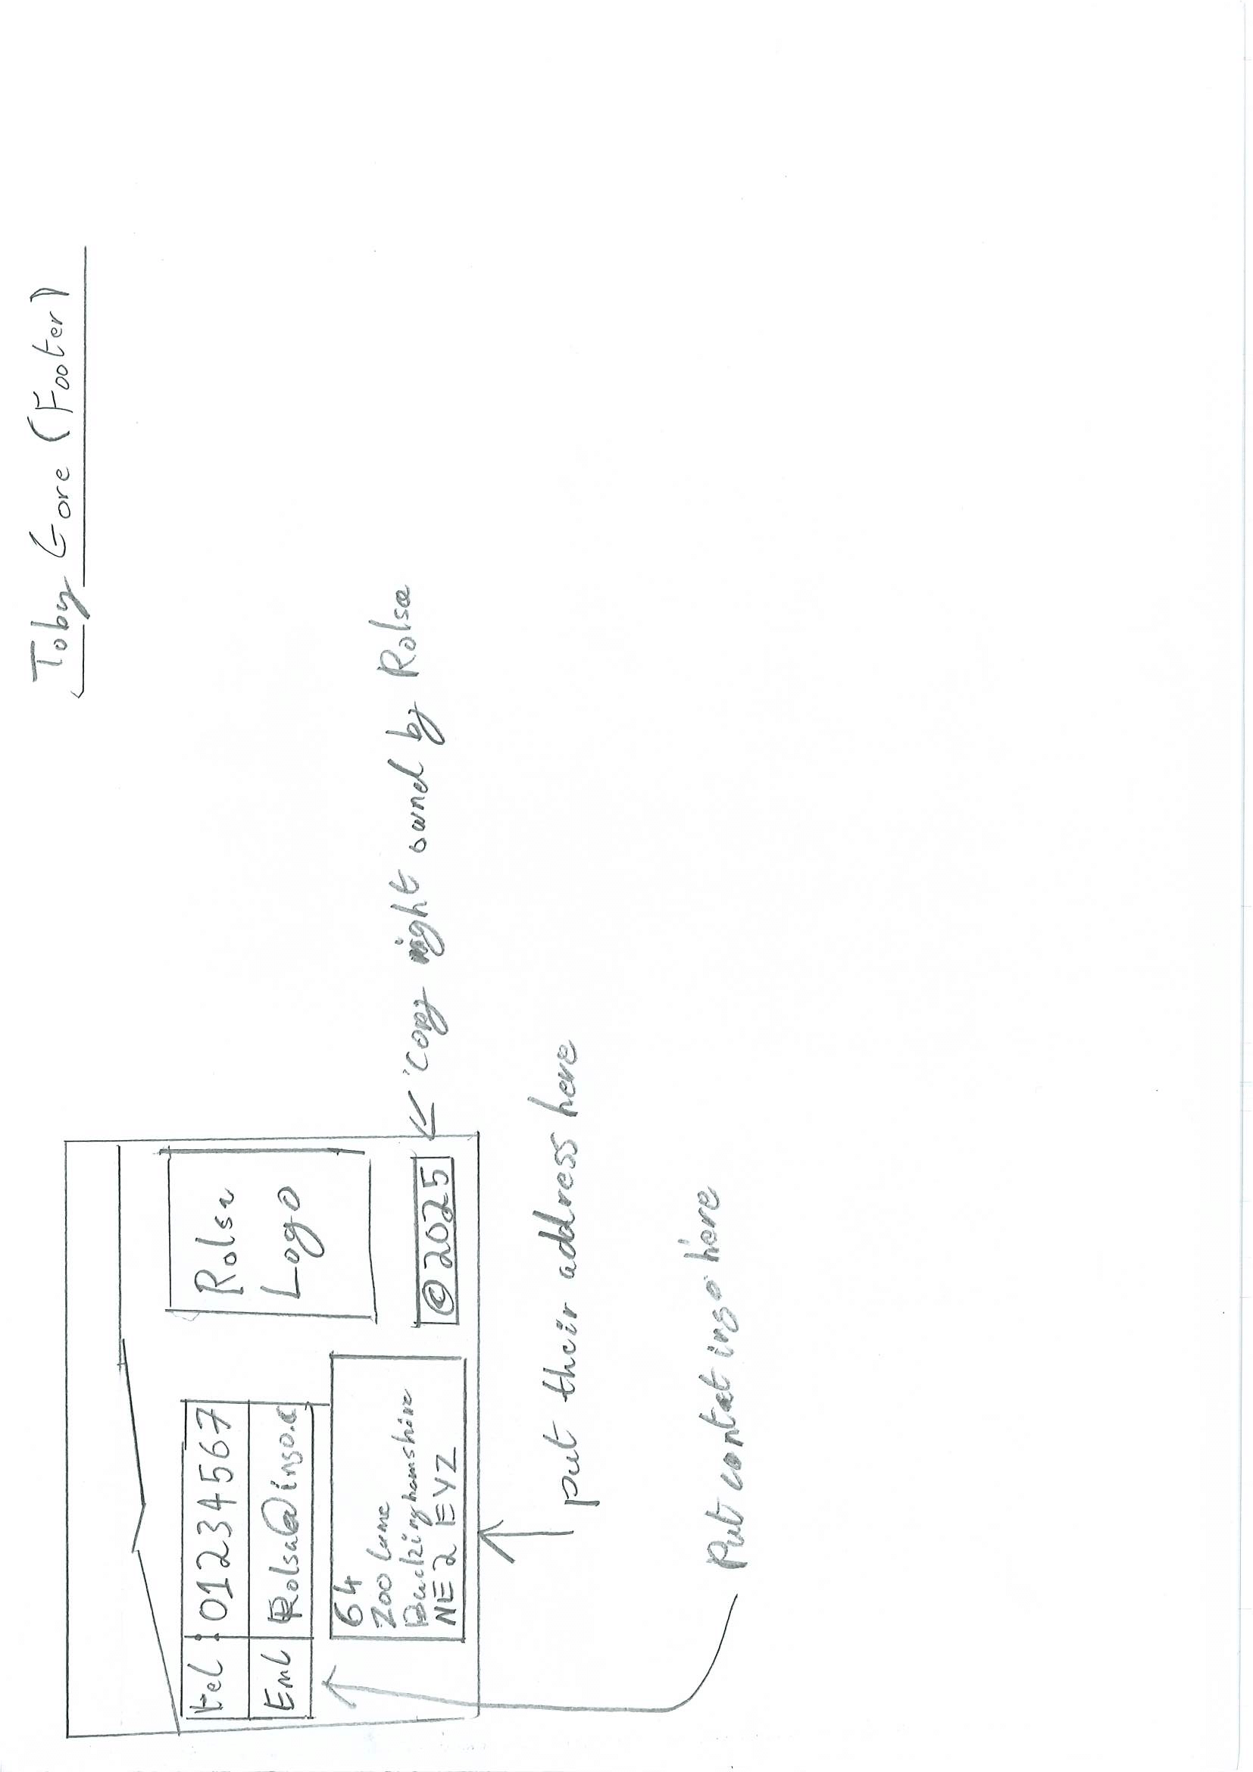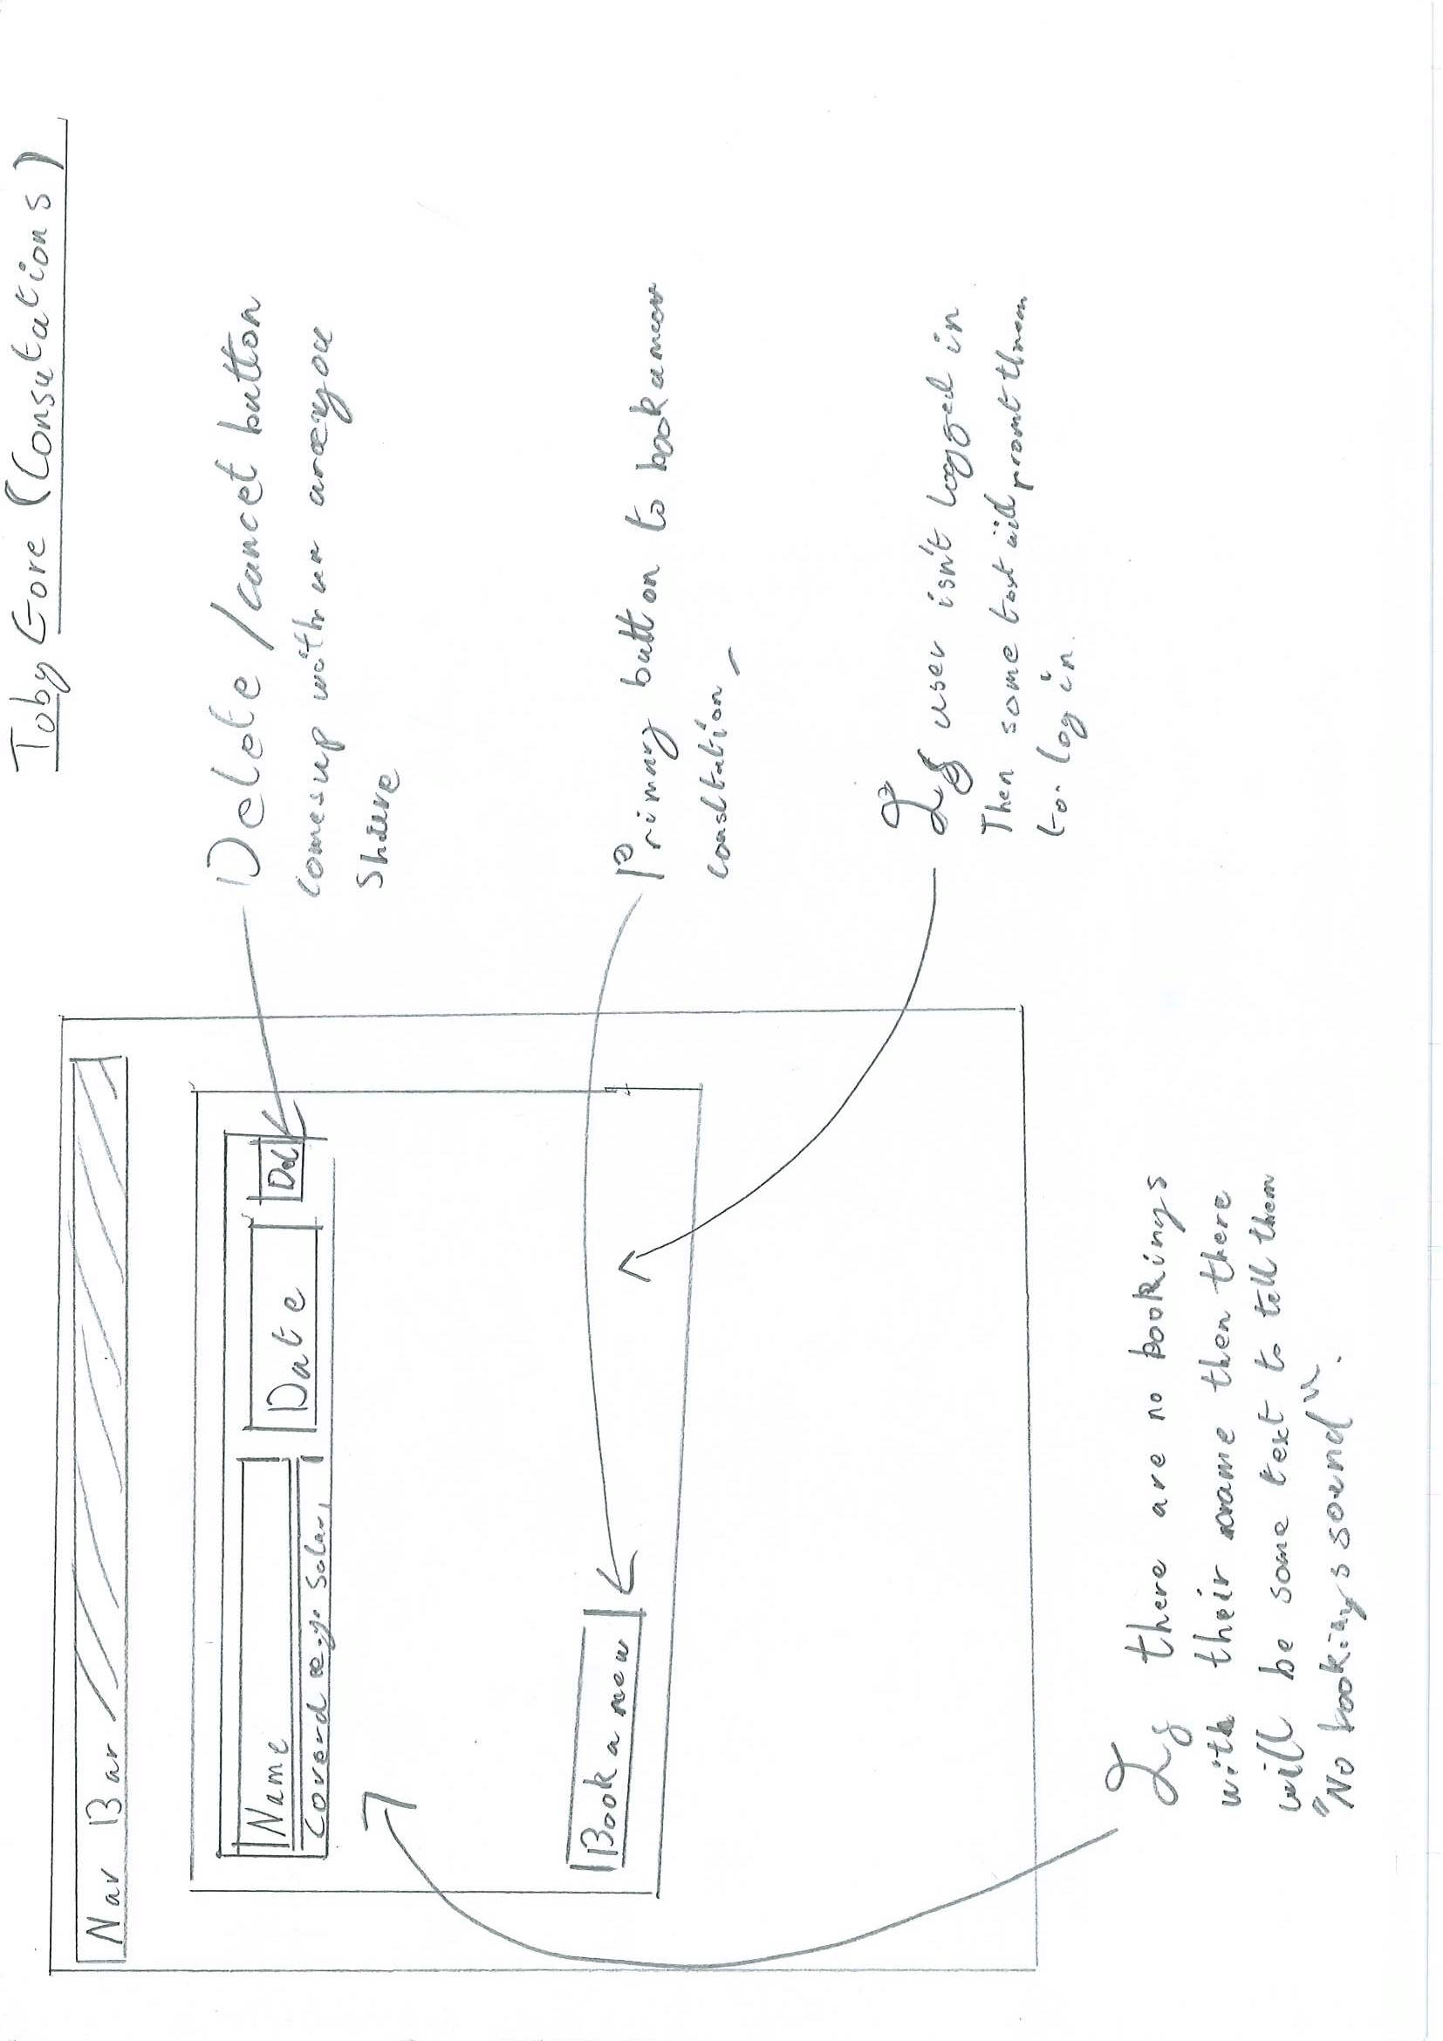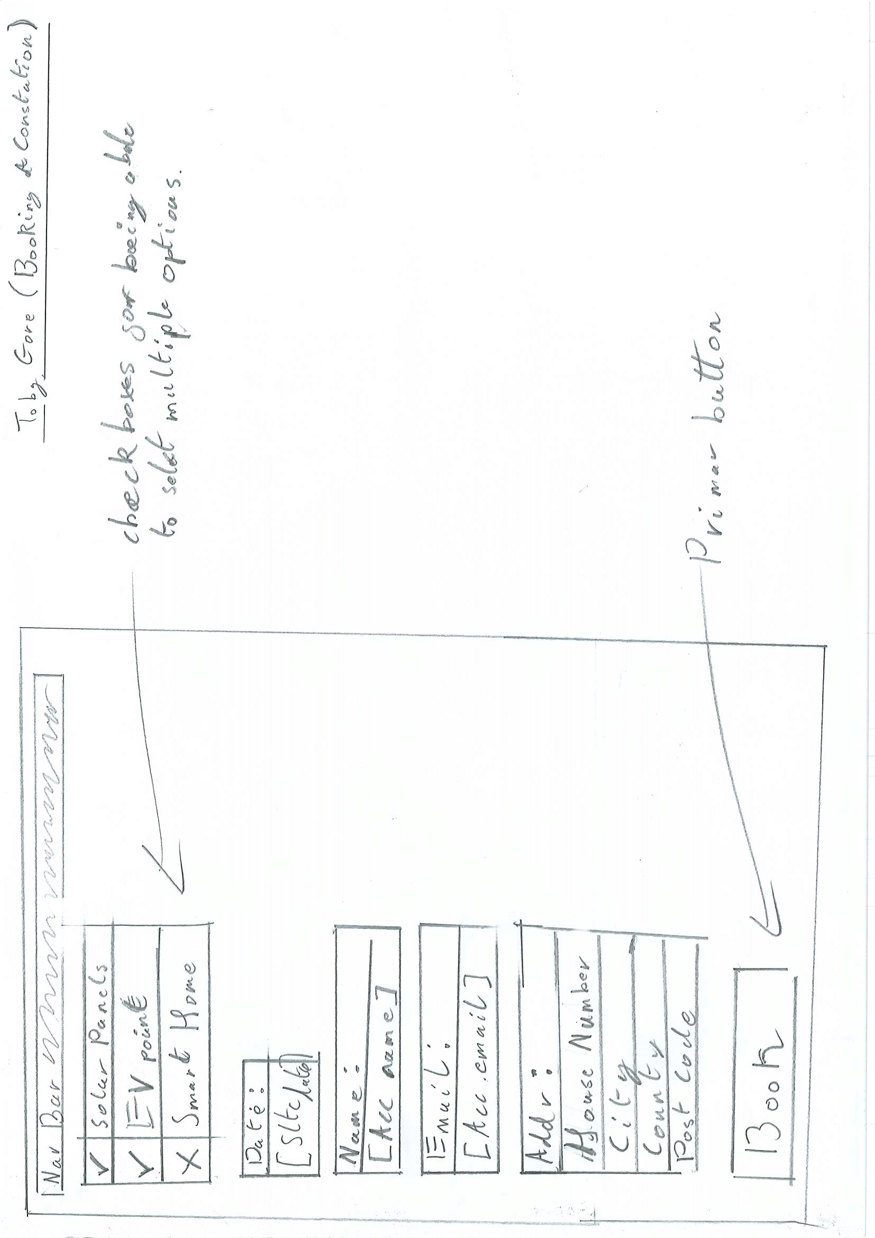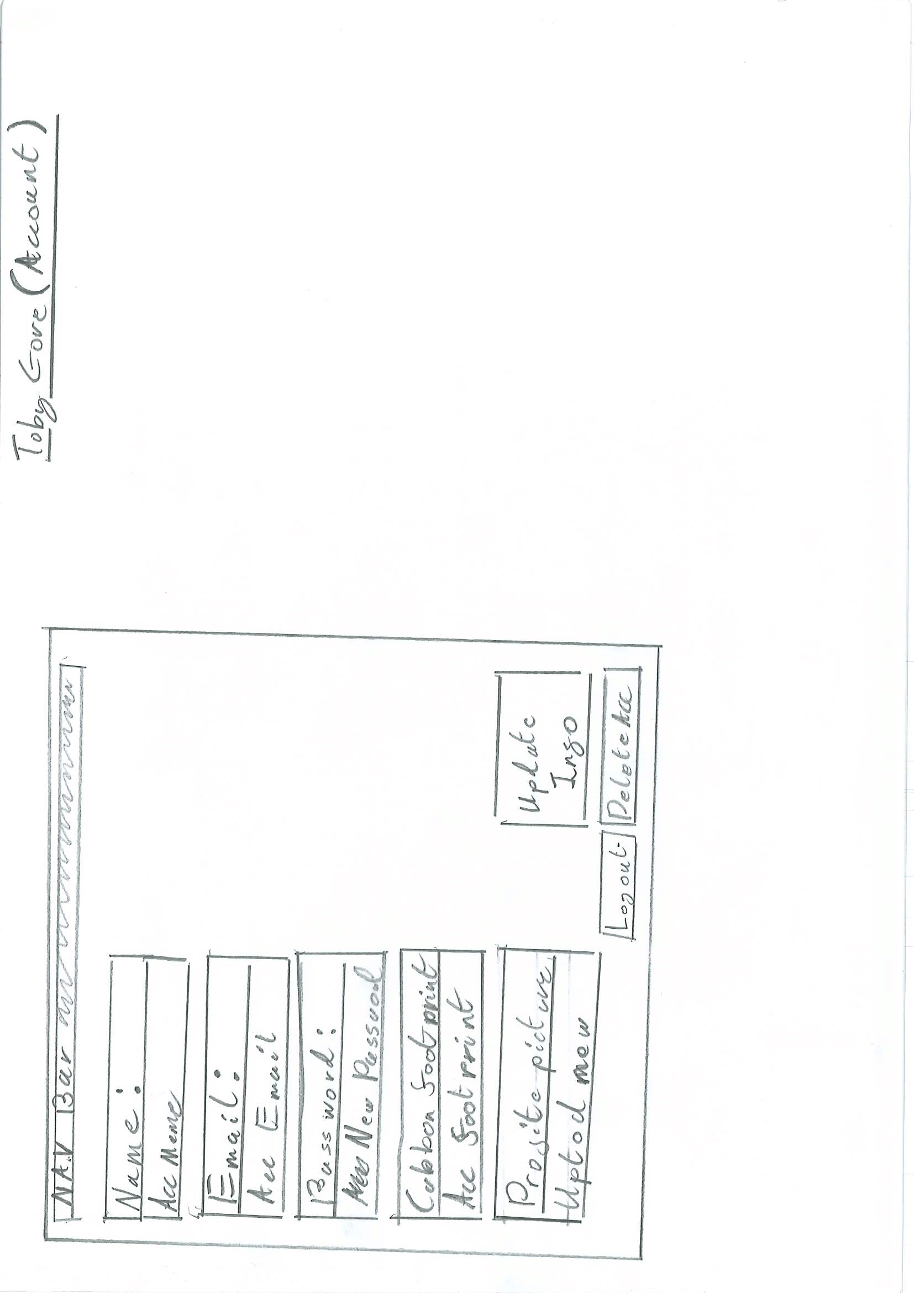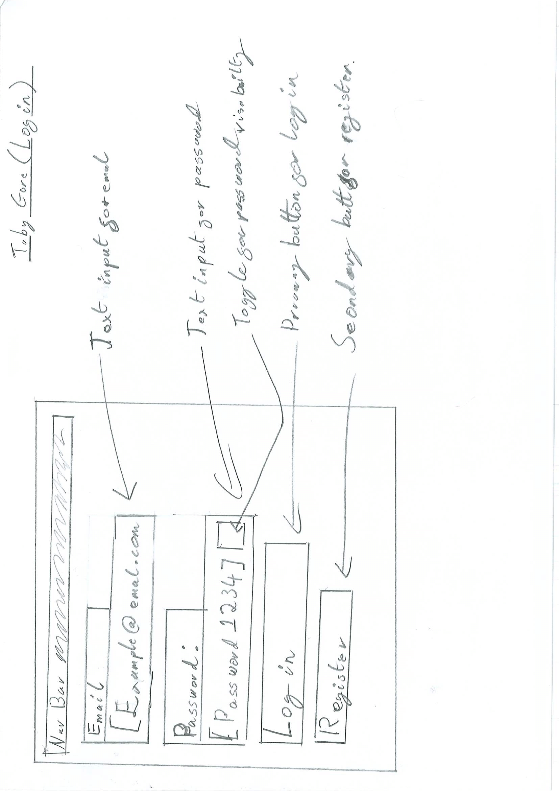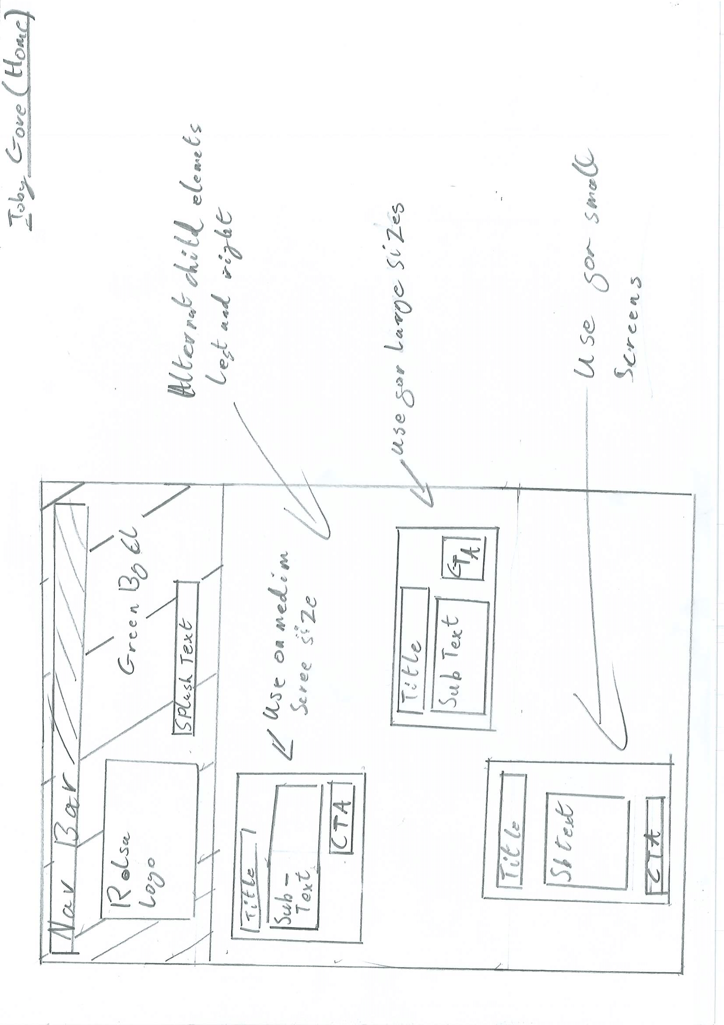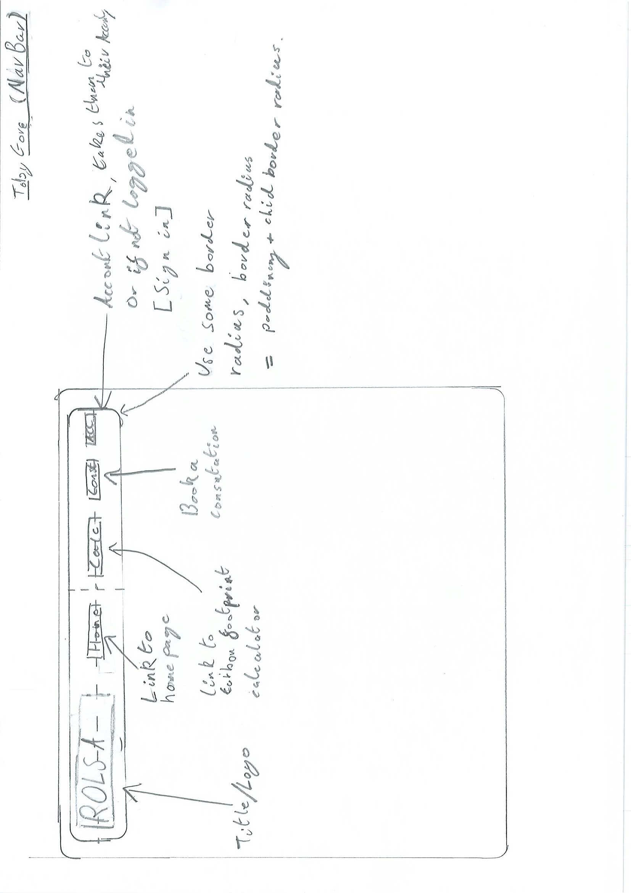

### High fidelity designs (subject to mild alteration)

#### Account

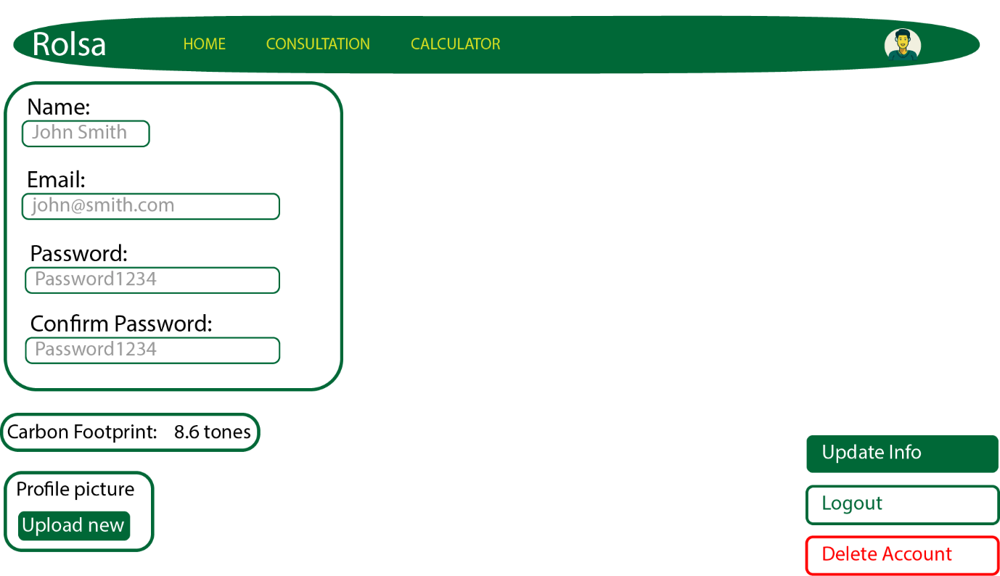

#### Create a booking

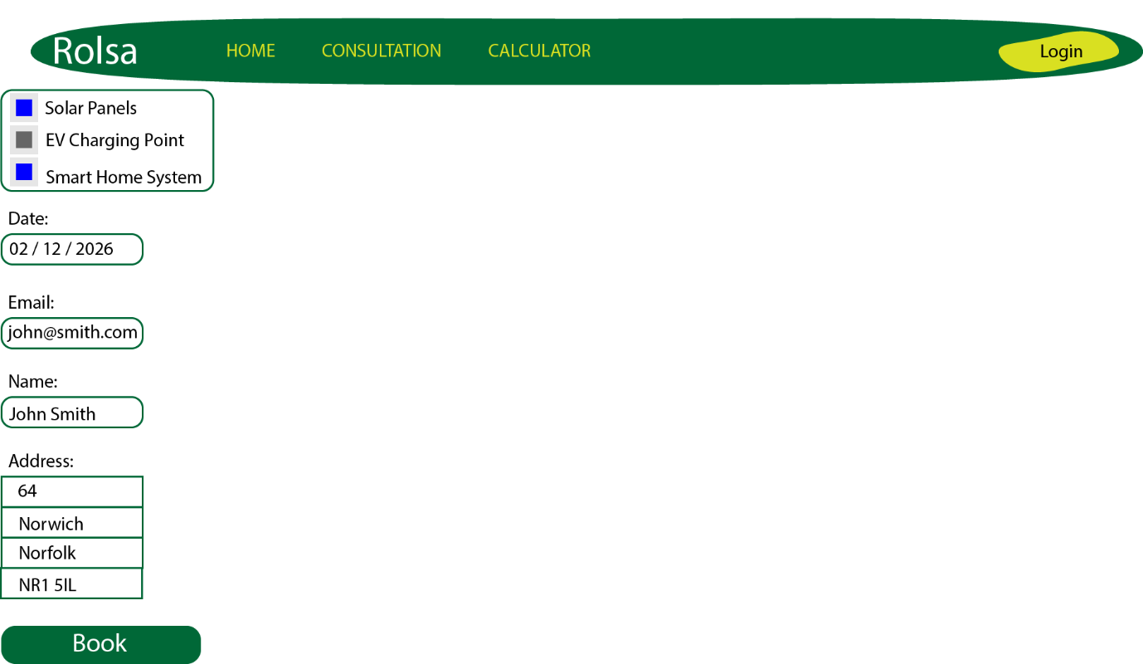

#### Quiz results

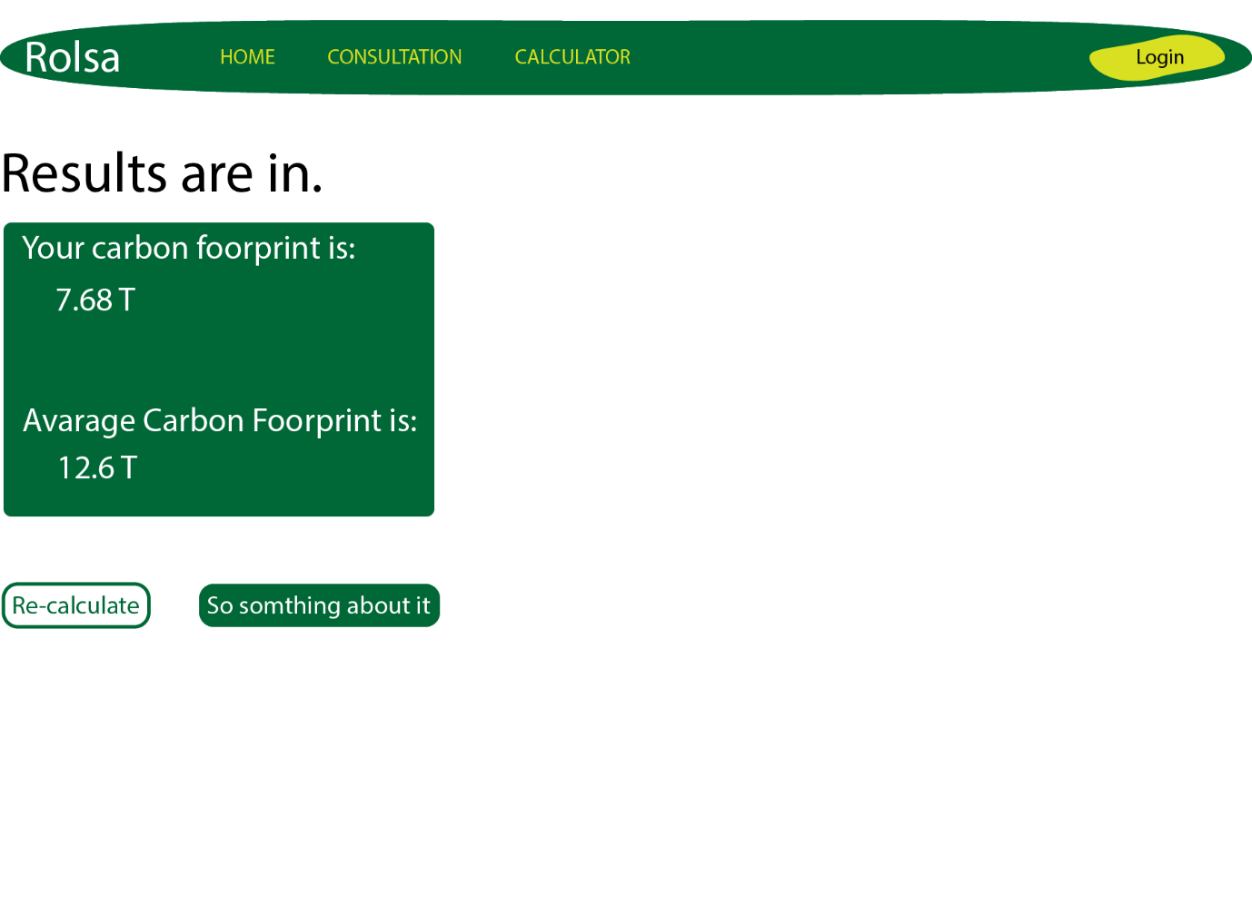

#### Quiz question

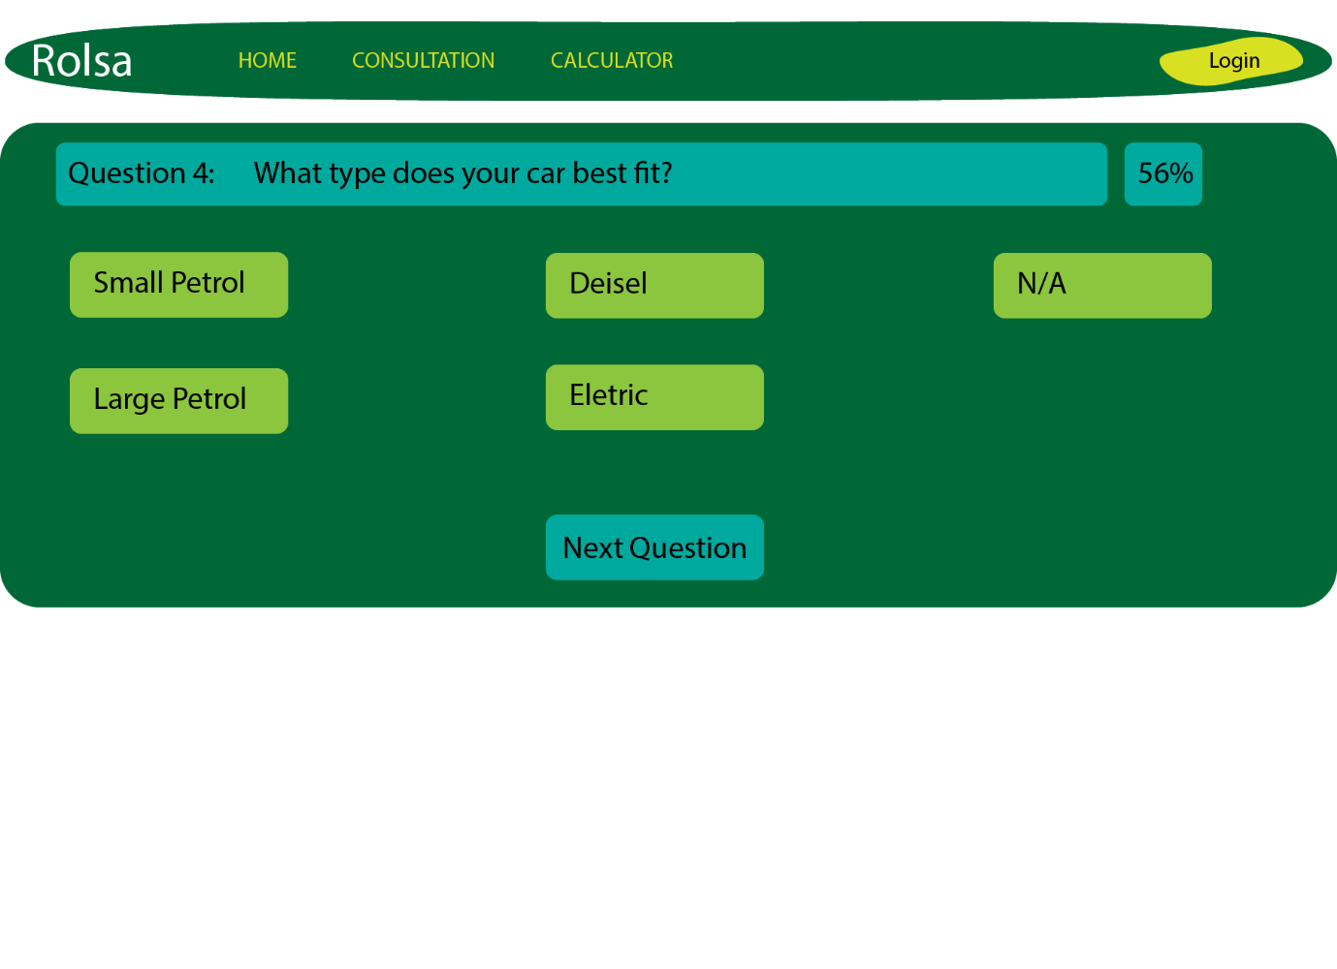

#### Home page

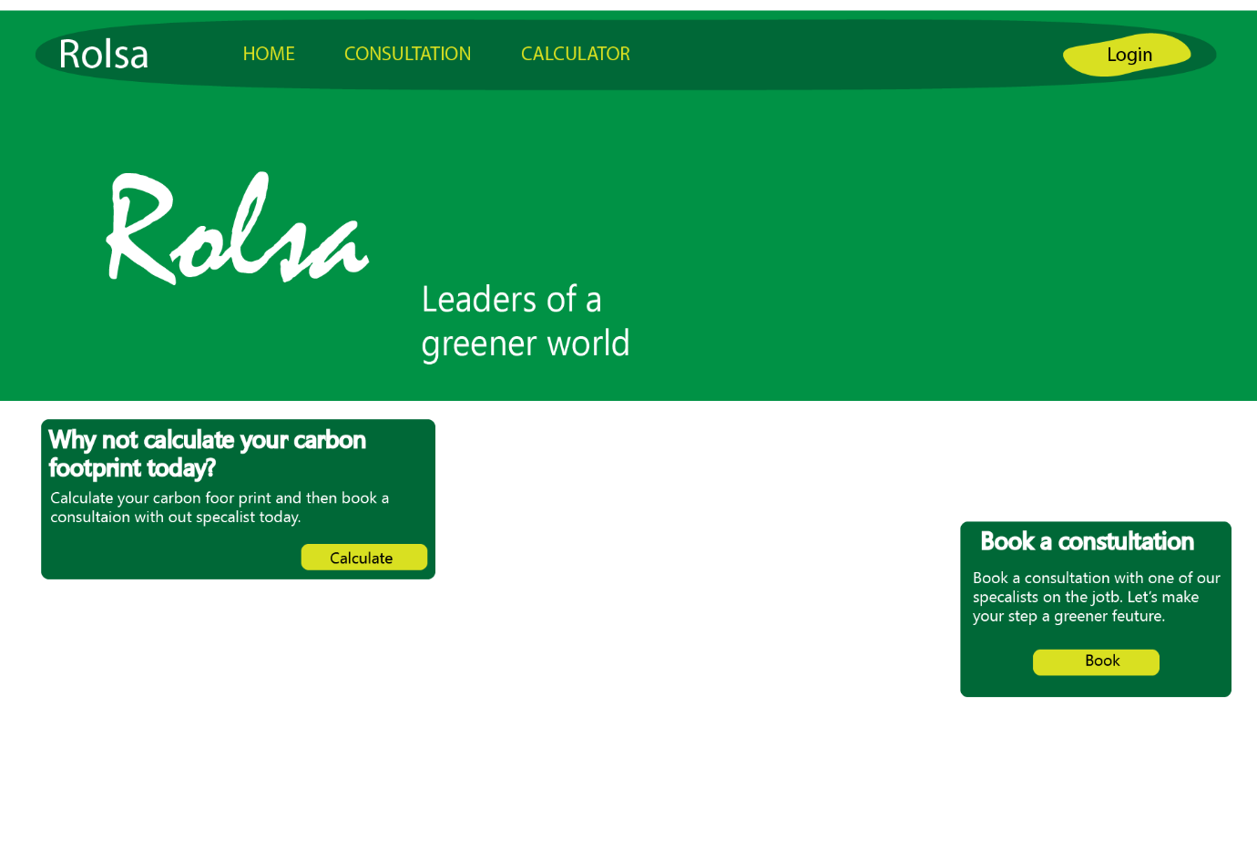

#### Login

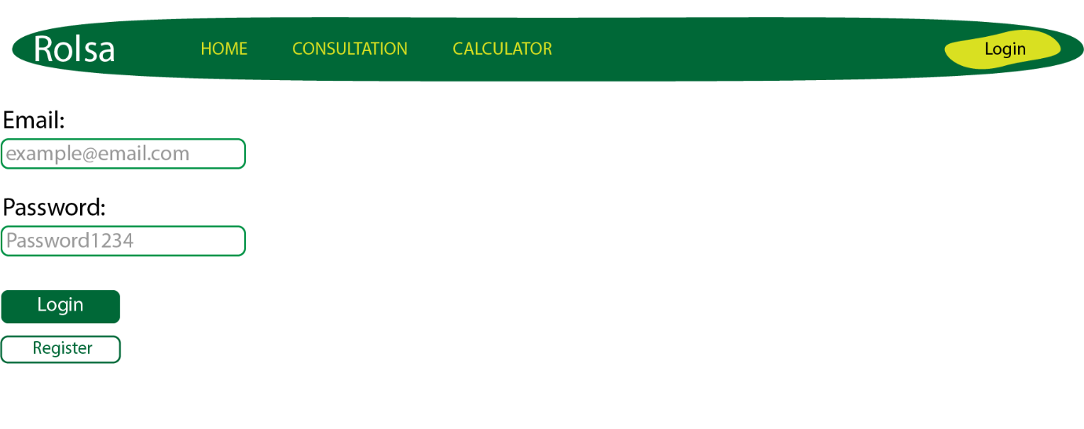

#### Navbar



#### Register

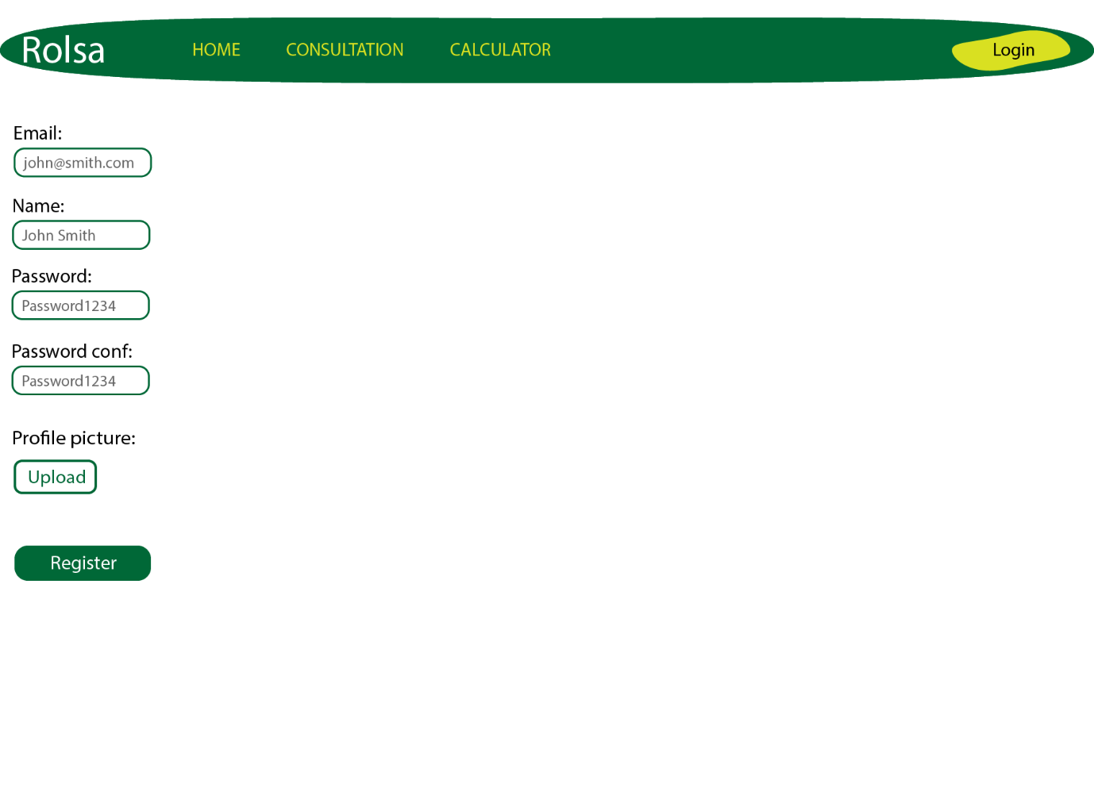

#### Bookings

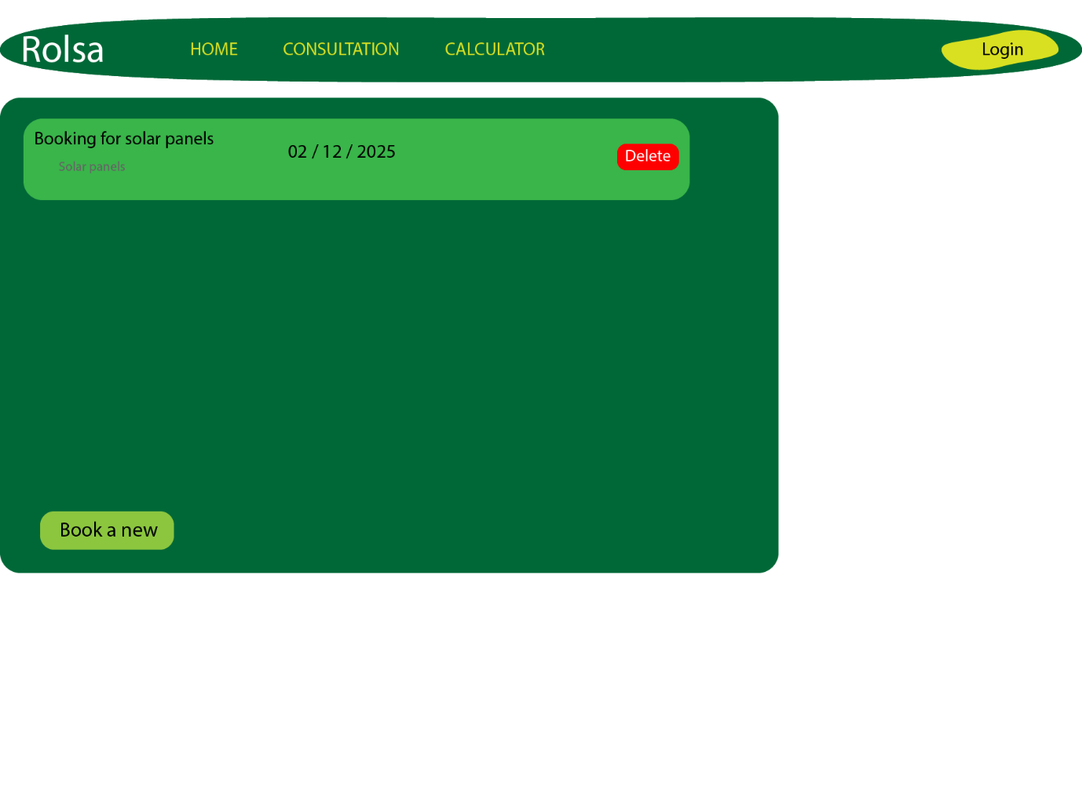

#### Footer

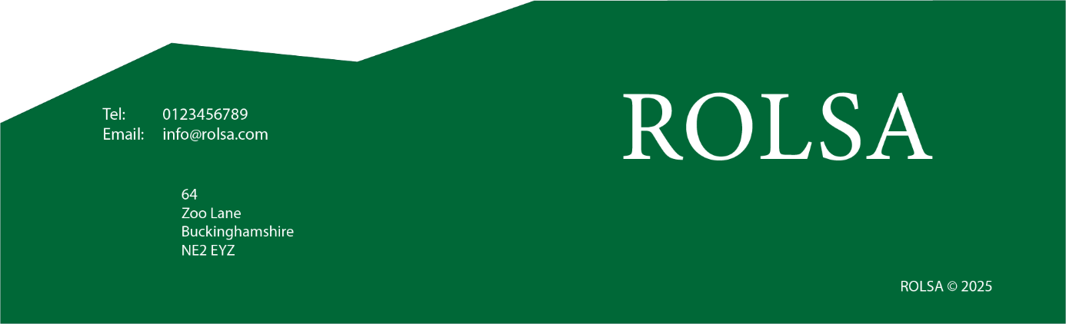

The design’s use text over icons, while there are common icons for home and login there is a lack of those same icons for calculations and bookings. To stray a way from text helps with the site migration to possible other languages such as German, Spanish, or Polish. To use icons where too much, but in future a better designer could add to the designs with icons.

# Data requirements

## Database

### Hand drawn table design

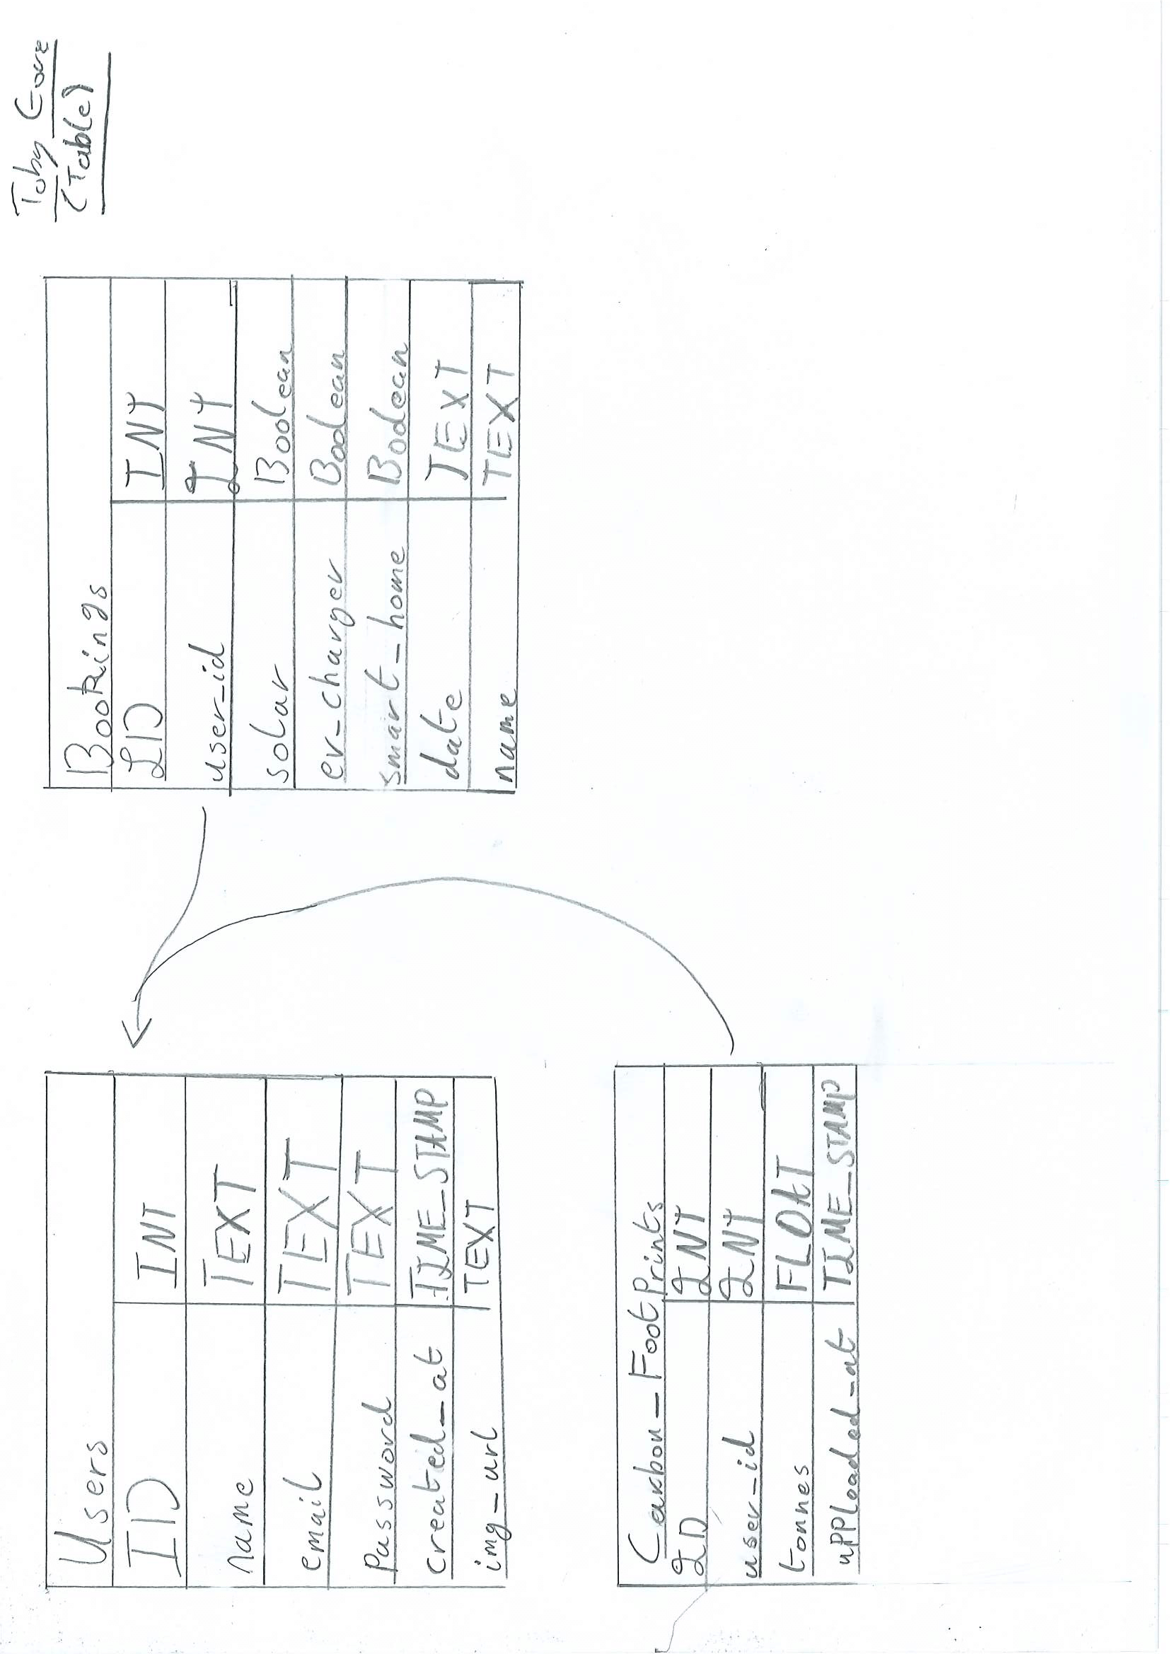

### General Notes

The ID field is used for external referencing and individual referencing, this is the primary key and auto incremented. All fields should not allow NULL unless specified otherwise.

### USERS

For the user’s name, email and password to go with a type of TEXT for the field as this allows the user to have as long of a name as to not discriminate against people with long names. Emails can be hefty in length sometimes and as such it seems silly to put a limit on that. The users’ password to be hashed and using sha256 the most common and difficult to break sha256 only use 256 chars, however, should a vulnerability appear with sha256 then it can be replaced by a different hashing algorithm. The img_url field which is not noted on there but is the only one that can be null, this is if the user would like to have an avatar. The TIME_STAMP is also created in case in future it should want to be used, with its default being TIME_NOW. On delete cascade to delete all tables with references to ID, all their bookings and all their footprint records.

### CARBON_FOOTPRINTS

The user_id references a user’s ID. The tonnes field holds the result of the calculation. The uploaded_at is a type of TIME_STAMP with its default of TIME_NOW, this can be used to see client footprints over time, or users could get reminders when their footprint calculation is over a few months old. With it having its own table user can see their own carbon footprint over time with multiple entries.

### BOOKINGS

User_id references a user’s bookings allowing the user to have multiple bookings and see their own bookings and not everyone’s all at once. Solar, ev_charger, and smart_home fields are all BOOLEANs to save space in storage and it makes it easier to work with as that will be the input type. The date field will be of type TEXT however it should follow standard date formats so that anyone can read date. Name holds the name for the booking in a type of TEXT for the field as their names of unknown length however a max character limit could be used with the type of VARCHAR.

## Data dictionary

### PHP variables

* User: map< string, string | double | null | int >
  + Img_url: string
  + Name: string
  + Email: string
  + Carbon footprint: double | null
  + Id: int
* Bookings: array< map< string, int | string | Boolean > >
  + Booking: map< string, int | string | Boolean >
    - Id: int
    - Date: string
    - Name: string
    - Solar: Boolean
    - Ev_charger: Boolean
    - Smart_home: Boolean
* Connection: mysqli
* Credentials: map< string, string > // sourced from the config.ini file
  + Username: string
  + Password: string
  + Database: string
  + url: string

### SCSS/CSS variables

* primary: colour
* secondary: colour
* tertiary: colour
* black: colour
* white: colour

### TypeScript/JavaScript variables

* questions: array
  + question: map
    - question: string
    - answers: map
      * answer: string
      * impact: number
* score: number
* currentQuestion: number // index to the current question in the array

### Asset Log

* Profile image placeholder, for users who do not have a profile picture
* Rolsa Logo, this will be a placeholder design made in Illustrator

# Algorithm design

## Initialisation of site

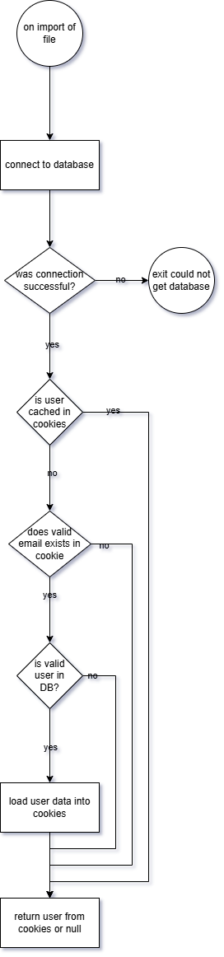

## User sign up

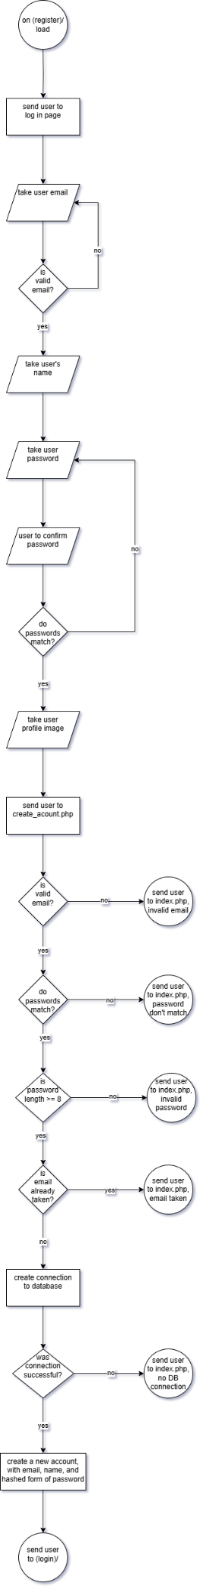



## Edit user account details

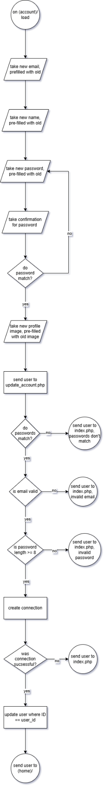

## Make a calculation

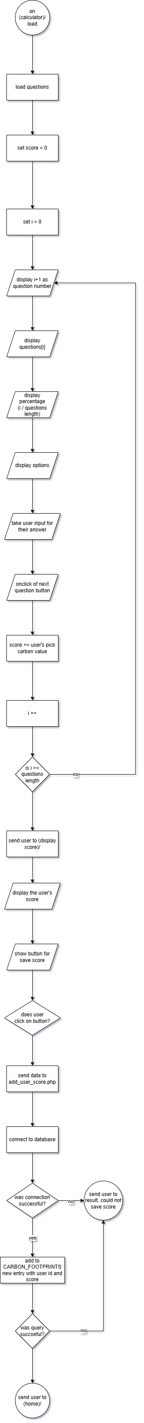



## Delete a booking

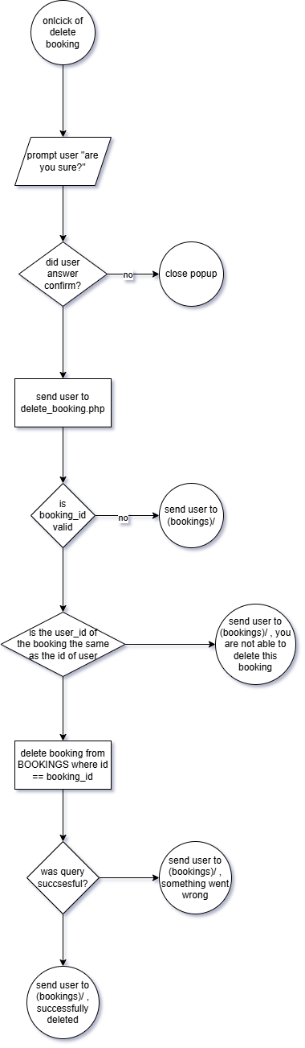

# Test strategies

## Importance of testing

From a blog about software testing (<https://www.testrail.com/blog/software-testing-strategies/>) written by Test Rail who are a software testing company based in the USA. Some real-world examples of companies who did not test properly or thoroughly enough, the royal bank of Scotland where unable to process 600,000 payments due a critical bug, Starbucks had to shut down over 60% of their stores dues to a POS system failure, Yahoo faced a data breach. To keep a business running well one should keep testing to a maximum as avoid easy to fix errors.

Automated testing could be used to help with some of the black box testing to speed up developments; for the scale of prototype, it may take too long to set up and most of its work could be done by hand.

The best software practices to hold to ensure not too long is spent debugging; robust code, to develop code that at each point is very hard to break, such as requiring strict types; clear documentation at each point either having a documentation document or building it into the source code in comments above each function. Clear test cases, in the documentation show use cases for the item at hand e.g. a function of “add” with arguments A and B that return the sum of the two. The best way to keep maintainable and robust code is to keep to coding standards.

### Programming standards on the web

Naming conventions are universally agreed on, with a W3C being the pillar for HTML. CSS uses kebab-case where only lower-case letters are used with hyphens separate words. With CSS for child elements a double underscore is used between class names when they are not already selectors in place. For JS camelCase is used where the first letter of each word is capital, all bar the first word. JS constants user UPPER_SNAKE_CASE where all the letters are upper-case, and the words are separated by under-scores. File names used snake_case where all words lower-case letters and separate words with under-scores.

## Types of strategies that can be used

### Black box

It is an absolute method of testing requiring very little knowledge of IT or programming, it ask Boolean like questions and expects the answer to be true. E.g. “can the use log in?”, it may be difficult and unconventional but if the answer is yes then it passes.

### White box

This is similar to black box but it more open answered and allows for improvements design, usability, and security.

### Code walkthrough

This takes another developer, and you walk them through the code so that they can help stop bugs and flaws with the system. It can be done solo with a rubber duck so that you the developer get your own understanding of it.

### Static code analyses

This is the use of well documented and clearly defined code bases to stop errors before they happen e.g. a function that takes two integer arguments is instead given 3 Boolean arguments in the code.

### Mutation testing

This is where errors and incorrect data are purposefully introduced into the code to test its robustness.

### Data flow test

This uses a series of logs to see the flow of data through the program, and spot where errors are spawning from. A memory viewer can also be used over log statements.

### Unit testing

This involves the inspection of each unit of code, this is especially handy in programs that are built with a modular mind set.

### Acceptance testing

This is getting user to test the software at hand and evaluates if it meets the spec given.

### Performance testing

this is used to test the pace of a website on things such as load times; a common tool industry is an open-source bit of software called JMeter.

## Test plan

|  |  |  |  |
| --- | --- | --- | --- |
| Test Name | Description | Type of test | Field |
| User sign up | The user is able to create a new account with Rolsa | Black box, white box, acceptance, unit | Account |
| User log in | Ther user is able to log into their account with Rolsa | Black box, white box, user acceptance | Account |
| Book consultation | The user is able to book a consultation at a specific date, type of consultation, and to where according to their address | Black box, white box, unit, static analyses | Consultation |
| Change account information | The user is able to change their information attached to their account | Black box, white box, mutation, data flow | Account |
| View and calculate carbon footprint | The user is able to see their carbon footprint attached to their account and calculate a new footprint | White box, mutation, unit | Carbon Footprint |
| Navigable site | The user is able to access all navigation links from the home page | Black box, performance, acceptance | Navigation |
| Cancel consultation | The user is able to cancel a booked consultation provided that the day is not on the day of their | Black box, white box, acceptance | Consultation |
| User log out | The user is able to log out of their account | Black box, white box, acceptance, mutation | Account |
| Delete user account | The user is able to request the deletion of their account | White box, black box | Account |
| Suggestions on how to reduce carbon footprint | Show the user how they can lower their carbon footprint with helpful links to internal resources and offer some external ones as well | Acceptance, performance | Carbon Footprint |
| Navigation to home | When the page loads the user should be put onto the home page | Performance, black box, acceptance | Home Page |
| Navigation to calculator | When the page goes to the calculator it should load, ask questions, and calculate the users carbon footprint, or ask them to sign in | Black box, white box, performance, acceptance | Carbon Footprint |
| Little to no PHP errors | The tech stack will use PHP, on most pages should be able to load without error > 95% of the time | Data flow, black box, static code, walkthrough | Backend |
| Home page with info on products | The home page should display useful and helpful information on the products and services the company offers | White box, acceptance | Home Page |
| Consistent colour scheme | The colour scheme should be same across the site with no Non-functional inconsistency | Acceptance | Theme |
| Consistent fonts | Fonts and spacing should stay the same for applications across the whole site | Acceptance | Theme |
| Light & Dark modes | Offer light and dark mode colour scheme for the website | Acceptance | Theme |
| Logo | Keep one logo for the whole site | Acceptance | Icon |
| Layout | Keep the same consistent layout of the site where boxes, nav links, and titles should be | Acceptance | Theme |
| Load time of under 3 sec | The load time of the website should be under 3 seconds when on localhost | Performance, black box, unit | Performance |
| Documentation | The documentation of the backend and frontend code should be comprehensive | Unit, static | Backend |
| Easy navigation | The layout of the site should be easy to navigate and find information you are after, e.g. links should be at the top where you expect them | Acceptance, white box | Theme |
| Mobile compatibility | The site retains all its features and is able to be used on mobile | Acceptance, black box, white box | Accessibility |
| Tablet compatibility | The site retaining all of its features is able to be used on a tablet device | Acceptance, black box, white box | Accessibility |
| Handle 100 concurrent users | The site should maintain reasonable performance over hosting 100 users | black box, white box, performance | Performance |
| Browser compatibility | The site should function and maintain similar styling across different browsers, Chrome, Firefox, Edge. | Whitebox | Theme |